**AED’s mHEALTH APPROACH FOR DESIGNING HEALTH ACTIVITIES**

**Background and Approach**

Pen and paper surveys, leaflets and brochures, one-on-one counseling have long been the tools used in behavior change and communication projects. The explosion of social media is about to change that, especially at that point where mobile and internet technology have fully integrated in handheld phones. The concept of the mobile phone panel is based on existing technology in this sphere, namely Wireless Access Protocol (WAP) and General Packet Radio Service (GPRS) systems. mHealth refers to the use of this mobile technology to support health programming. mHealth projects have three common elements: the use of electronic information and communication technology; mobility of services, providers and/or clients; and application to one or more components of the health system.

In order to set up an effective mobile phone panel we do not just consider the capability of the technology. The application must take the development objectives into account and more importantly, consider the capacity of the participants, the panel members who will delivery of the data on a regular basis.

AED determined that mobile phone panels have a unique set of advantages that traditional face to face or even phone based monitoring systems cannot match. These include not being reliant on interviewers, as data are sent out from a computer and collected without human intervention; having automatic reminders sent out in the case of non-responders; most people already owning the technology required; offering a high level of confidentiality and non-intrusiveness, as people can submit data whenever they want; and reducing the cost of data collection overall.

**Data Collection System Flow**

**Verification Phone**

* Recruit key participants in target areas.
* On-line registration and testing
* Send out ‘SMS Link’ with link to a WAP Site
* Data capture on WAP Site
* Server with secure data storage
* Follow up and verification
* Reporting interface

In summary, the advances in mobile technology have moved many applications from the office desktop directly to the hands of staff in the field including resulting in opportunities in:

* Data collection – program monitoring, surveys, client records
* Education, training and job aids – reinforcement, assessment, supportive supervision
* Behavior change & communication – health tips, service availability, treatment compliance reminders
* Supply chain management – tracking shipments, preventing leakage, eliminating stock-outs

AED has designed several mHealth projects in Asia that take advantage of these opportunities.

**LAO PDR – Engaging the Lao Women’s Union to Avert Infectious Disease Outbreaks via Info Sharing**

As part of evaluating different rapid-response mechanisms to outbreaks in Laos and other countries in the greater Mekong Region of Southeast Asia, AED realized that the Lao Women's Union’s (LWU) capacity to move community outreach and mobilization during disease outbreaks and pandemic can be further strengthened if they were introduced and trained on the use of SMS technology. With support from USAID RDMA, in November 2010 AED’s MID-BCC Project set up a rapid response mechanism with LWU to monitor public health initiatives in cross-border sites in and around Vientiane, Savannakhet, Luang Namtha and Bokeo. The process was to initially train a group of Master Trainers who in turn would go back to their city and train additional panel members.

AED set up a WAP-based system where panel participants could report directly via a GPRS internet connection using their own mobile phones. Data were submitted straight from the phone to a final database, enabling the collection of data anywhere there was mobile phone coverage and GPRS available. Panel members were pre-screened to ensure their literacy and ability to use SMS on their mobile phone.

A scheduled SMS link was sent to every panel member on a weekly basis for 4-6 weeks. The link led users to a WAP hosted survey that included 1-6 questions in the local language. All data submitted by panel participants was monitored through an on-line administrator site, which also tracked non-response and potential drop-outs across all panel members.

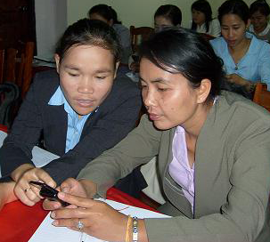

Figure : LWU Members at Training

**SOUTHEAST ASIA CROSS-BORDER – Engaging Communities in the Monitoring of Market Price on the Mukdahan, Thailand and Savannakhet, Lao PDR Border.**

As part of the USAID partners’ cross-border joint effort, AED under MID-BCC Project collaborates with FAO in providing a communication platform for local communities to report prices and other information that will contribute to a monitoring system that targets unusual spikes in market prices, indicating possible disease outbreaks in the locality. The intervention is organized to collect market data in four markets in Mukdahan and Savanakhet. In Lao PDR, members from the Laos Women’s Union that participated in the early SMS project (see above) were recruited. In Mukdahan, with assistance from the local office of the Department of Livestock Development, 15 market vendors were recruited for the activity (photo of vendor training below).

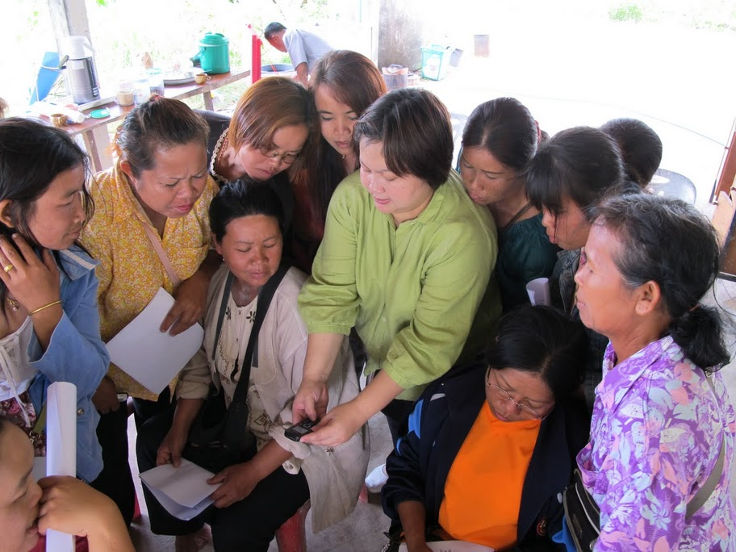

Figure : Market Vendor SMS Orientation in Mukdahan, May 2011

The SMS interventions are designed to be rapid and simple to participate in. For the monitoring activity, three questions are sent out on a weekly basis. The data sent back will be compiled into “flash reports” by AED and then the trend data analysed by FAO. The questions are:

1) How much (THB/LAK) do you pay for 1 kg of slaughtered local chicken this week?

2) How much (THB/LAK) do you pay for 1 chicken egg this week?

3) How much (THB/LAK) do you pay for 1 black piglet this week?

**THAILAND – Utilization of SMS Messaging with Burmese Migrant Health Volunteers to Mitigate Malaria Risk in Phuket.**

Under the USAID-funded MID-BCC Project, AED is preparing in the summer of 2011 to establish a rapid response mechanism in Phuket within the Burmese migrant communities. The intention is to use the system to collect data and disseminate information (Alert Messages) to strengthen the ability of migrant communities to avoid the risk of malaria and other vector borne diseases, and report suspected outbreaks. The panel members will be migrant health volunteers recruited by the Provincial Health Office. Topics of interest include:

1. Symptoms in patients
2. Suspect malaria or dengue cases
3. Potential outbreaks
4. Dissemination of information regarding prevention (planned distribution of nets, reminders to use repellent when working outside, promotion of village ‘clean up’ campaigns to remove open containers etc, adherence to malaria treatment protocols.)

The outcome sought is that the panel will contribute to shared information and reduce the risk of a potential dengue or malaria outbreaks. Based on past experience, from establishing similar panels with health care workers in the Philippines and in Laos, AED would like to again set up a WAP based system where panel participants can report directly via GPRS using their own mobile phone.

**PHILIPPINES: Engaging Health Care Workers to Monitor H1N1 Vaccination Campaign in Manila**

To monitor the progress of a vaccination campaign for H1N1, the pandemic influenza virus, in March 2010, AED created a mobile phone-based reporting system to collect information from health care workers – or those who would be doing the vaccinating – on a weekly basis. The activity was part of the USAID-funded PREVENT Global Avian Influenza and Zoonotic Behavior Change and Communication Support project, and was intended to determine communication needs for the campaign.

AED recruited 48 health care workers and supervisors from different health clinics in Manila and invited them to two training sessions over two days that included using a test link with mock questions on their phones. For four weeks, AED sent messages each Friday soliciting information on H1N1 vaccination activities. The message contained a link that connected participants to the internet and brought them to a WAP site (using a standard GPRS connection to the internet), where six close-ended questions were posted. When the last question was answered the data were transferred to a secure server. AED followed up with non-responders after 24 hours.

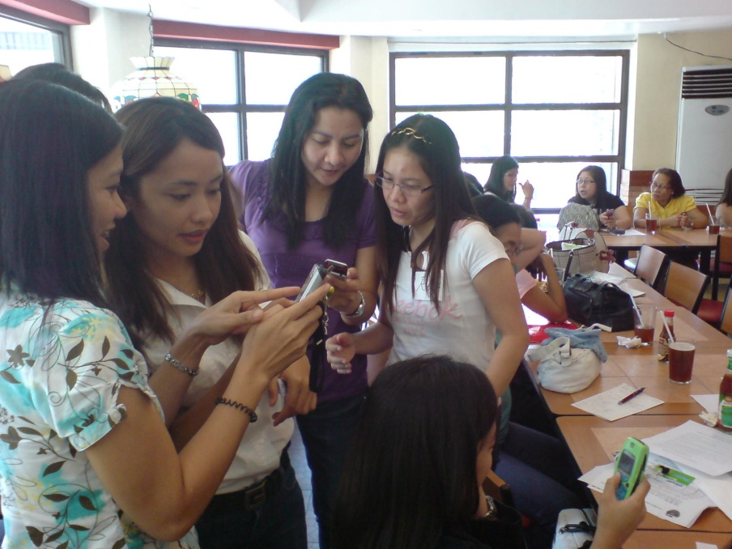

Figure : Philippines Health Care Worker Training for H1N1 Intervention

**NEPAL – Engaging Animal Health Workers and Local NGOs in Reporting on Perceptions and Awareness of Avian Influenza Outbreaks**

As part of the USAID-funded AI.COMM global avian and pandemic influenza project, AED implemented a mobile phone-based reporting system called GATHER™ in Nepal in August 2009 for gathering and reporting on perceptions and awareness of avian influenza outbreaks. This pilot study engaged animal health workers who were pre-selected by AI.COMM from a local NGO, SWSTIKA.

AI.COMM used Nepal Telcom, the largest service provider in Nepal, and offered post-paid accounts to incentivize panel members to participate. Following an initial training on the system in Kathmandu, the team travelled to the Chitwan valley to screen and train the local NGO members based on a pre-set protocol that included learning how to upload, complete, and send survey forms. A total of 20 NGO members were trained over a two day-period.

**TANZANIA – Engaging religious leaders in HIV counseling**

As part of educating religious leaders on how to counsel couples on HIV/AIDS prevention and faithfulness under the USAID-funded T-MARC Project, mobile technologies were used to maintain a connection between the leaders following their counseling training workshops. Following a one-day training on basic HIV prevention facts and how to counsel couples, the religious leaders were asked to report what type of counseling they were involved with for up to a month following their training. This was intended to provide support to the leaders, if needed, and also to better understand the types of questions and concerns they are confronted with related to HIV and faithfulness. Sending SMS messages to participants’ mobile phones, the project asked questions such as “how many people do you counsel in one day” and “which people came for counseling”?

In the first two weeks of the activity, the project received 431 responses from religious leaders. Initial experience indicates that participants should be given the opportunity to give multiple answers followed by an automated response, but that overall, there were very few revisions that needed to be made, and very few errors made by the participants.